**Bahria University,**

Karachi Campus



## LAB EXPERIMENT NO.

## 7

## LIST OF TASKS

|  |  |
| --- | --- |
| **TASK NO** | **OBJECTIVE** |
| **1** | Write a python program to implement the support vector machine on Diabetes dataset. implement the following different kernels of SVM and compare the accuracy score and visualize the confusion matrix and hyperplane. |
| **2** | Design the workflow with the help of KNIME to implement the Support Vector Machine Algorithm on any classification dataset |

**Submitted On:**

18 feb 2024

(Date: DD/MM/YY)

**TASK 1: Write a python program to implement the support vector machine on Diabetes dataset. implement the following different kernels of SVM and compare the accuracy score and visualize the confusion matrix and hyperplane.**

**SOLUTION:**

import pandas as pd

from sklearn.model_selection import train_test_split

from sklearn.preprocessing import StandardScaler

from sklearn.decomposition import PCA

import matplotlib.pyplot as plt

import numpy as np

file_path = 'diabetes.csv'

diabetes_data = pd.read_csv(file_path)

diabetes_data.head(), diabetes_data.describe(), diabetes_data.isnull().sum()

columns_to_fix = ['Glucose', 'BloodPressure', 'SkinThickness', 'Insulin', 'BMI']

for col in columns_to_fix:

diabetes_data[col] = diabetes_data[col].replace(0, diabetes_data[col].median())

X = diabetes_data.drop('Outcome', axis=1)

y = diabetes_data['Outcome']

X_train, X_test, y_train, y_test = train_test_split(X, y, test_size=0.2, random_state=42)

scaler = StandardScaler()

X_train_scaled = scaler.fit_transform(X_train)

X_test_scaled = scaler.transform(X_test)

X_train_scaled[:5]

columns_to_fix = ['Glucose', 'BloodPressure', 'SkinThickness', 'Insulin', 'BMI']

for col in columns_to_fix:

diabetes_data[col] = diabetes_data[col].replace(0, diabetes_data[col].median())

X = diabetes_data.drop('Outcome', axis=1)

y = diabetes_data['Outcome']

X_train, X_test, y_train, y_test = train_test_split(X, y, test_size=0.2, random_state=42)

scaler = StandardScaler()

X_train_scaled = scaler.fit_transform(X_train)

X_test_scaled = scaler.transform(X_test)

kernels = ['linear', 'poly', 'rbf']

models = {}

predictions = {}

accuracy_scores = {}

for kernel in kernels:

svm_model = SVC(kernel=kernel, gamma='auto')

svm_model.fit(X_train_scaled, y_train)

y_pred = svm_model.predict(X_test_scaled)

models[kernel] = svm_model

predictions[kernel] = y_pred

accuracy_scores[kernel] = accuracy_score(y_test, y_pred)

print(accuracy_scores)

fig, axes = plt.subplots(1, 3, figsize=(18, 5))

fig.suptitle('Confusion Matrices for Different SVM Kernels')

for ax, kernel in zip(axes.flatten(), kernels):

confusion_mtx = confusion_matrix(y_test, predictions[kernel])

sns.heatmap(confusion_mtx, annot=True, fmt='d', cmap='Blues', ax=ax)

ax.set_xlabel('Predicted labels')

ax.set_ylabel('True labels')

ax.set_title(f'Kernel: {kernel}')

plt.tight_layout(rect=[0, 0.03, 1, 0.95])

plt.show()

def plot_hyperplane(clf, X, y, h=0.02, draw_sv=True, title="Decision Boundary"):

x_min, x_max = X[:, 0].min() - 1, X[:, 0].max() + 1

y_min, y_max = X[:, 1].min() - 1, X[:, 1].max() + 1

xx, yy = np.meshgrid(np.arange(x_min, x_max, h),

np.arange(y_min, y_max, h))

plt.figure(figsize=(12, 8))

Z = clf.predict(np.c_[xx.ravel(), yy.ravel()])

Z = Z.reshape(xx.shape)

plt.contourf(xx, yy, Z, alpha=0.8, cmap=plt.cm.coolwarm)

plt.scatter(X[:, 0], X[:, 1], c=y, cmap=plt.cm.coolwarm, s=20, edgecolors='k')

if draw_sv:

sv = clf.support_vectors_

plt.scatter(sv[:, 0], sv[:, 1], c='yellow', marker='x', s=100, linewidths=2, edgecolors='k')

Z = clf.decision_function(np.c_[xx.ravel(), yy.ravel()])

Z = Z.reshape(xx.shape)

plt.contour(xx, yy, Z, colors='k', levels=[-1, 0, 1], alpha=0.5, linestyles=['--', '-', '--'])

plt.title(title)

plt.xlabel('Principal Component 1')

plt.ylabel('Principal Component 2')

plt.show()

plot_hyperplane(svm_model_pca, X_train_pca, y_train, title="SVM Decision Boundary with Linear Kernel")

**OUTPUT:**

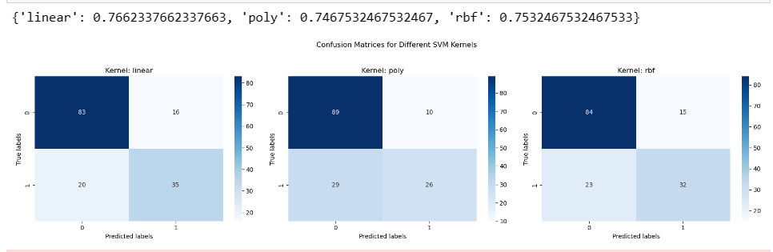

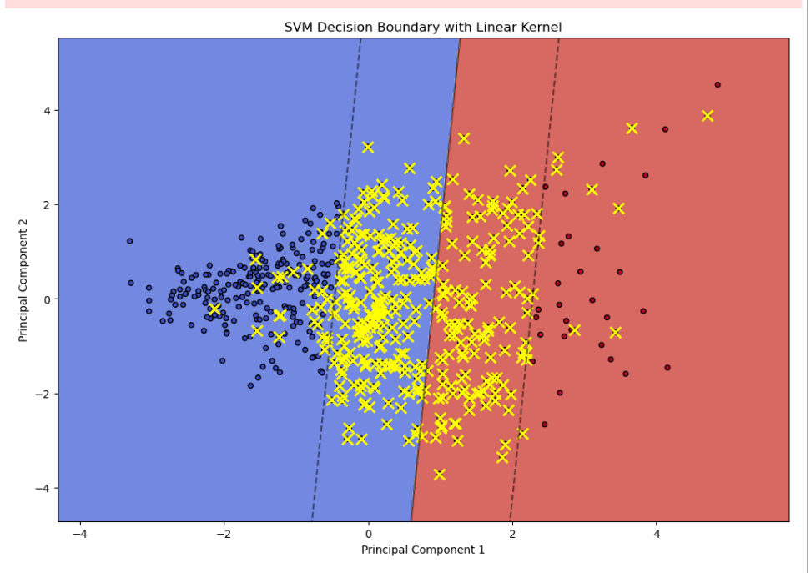

**TASK 2:** **Design the workflow with the help of KNIME to implement the Support Vector Machine Algorithm on any classification dataset**

